Honors Chemistry: Acids and Bases Unit Objectives

By the end of the unit, students should be able to:
- Introduction to acids and bases
  - List the properties of acids and bases
  - Classify a substance as an acid or base based on its chemical formula
    - Always refer to Reference Tables K and L
    - Know the exceptions: Compounds that contain –OH but are NOT bases
      - Alcohols: compounds with ONLY C, H, and then an OH, such as CH₃OH
      - Organic Acids: end in –COOH, but are ACIDS, NOT BASES, such as ethanoic acid: CH₃COOH (on Table K)
- Acid and Base theories
  - Explain how Arrhenius defined acids and bases according to the specific types of ions they produce in solution
  - Explain how Bronsted and defined acids and bases (BAAD)
    - Identify the acids and bases in a chemical equation
    - Identify conjugate pairs in a reaction
    - Define amphoteric substance and give an example.
  - Know the difference between Lewis acids and bases in terms of electron pair transfer and be able to identify if a substance acts like a Lewis acid or base
- Anhydrides
  - Identify acidic and basic anhydrides
  - Determine the formula of the acid or base that forms when an anhydride dissolves in water.
- Acid and Base strength
  - Memorize the rules for identifying strong and weak acids and bases from their formulas
  - Know the difference between strong and weak acids in terms of ionization
  - Write the equations for ionization of an acid or base in water
  - Perform calculations with ionization constants (K_{a} or K_{b})
  - Know the relationship between the value of Ka and the strength of an acid
  - Calculate the percent ionization of an acid
- pH scale
  - Memorize and be able to use the following formulas:
    - [H₃O⁺] x [OH⁻] = 1.0 x 10⁻¹⁴
    - pH = - log [H₃O⁺]
    - [H₃O⁺] = 1.0 x 10^{-pH}
  - Classify a substance as an acid or a base based on its pH number
  - Calculate the pH of substance if given the concentration of H⁺/H₃O⁺ and vice versa
  - Know what happens to the concentrations of hydronium ion and hydroxide ion as pH decreases (gets more acidic) or increases (gets more basic)
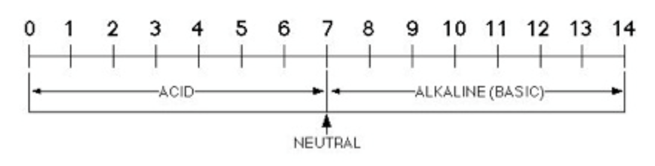
  - Calculate how many times the [H⁺/H₃O⁺] increases/decreases for a change in each step on the pH scale
High [H+/H₃O⁺]
Low [OH-]
Low [H+/H₃O⁺]
High [OH-]
[H+/H₃O⁺] = [OH-]
- Indicators
  - Use Table M to determine what color a given indicator would appear for a solution at a certain pH
- Reactions involved with acids and bases
  - Predict the products in a reaction of an acid with a metal
  - Predict the products in a reaction of an acid with a base (a neutralization reaction)
  - Identify if the hydrolysis of a particular salt would form an acidic or basic solution
- Titration
  - Explain why a titration would be performed
  - Use the Titration Formula on Table T to calculate the unknown concentration or volume in a titration problem
    - *Make sure to multiply the M_{A}V_{A} side by the # of H⁺ in the acid, and the M_{B}V_{B} side by the # of OH⁻ in the base

